**SITE ENVIRONMENTAL MANAGEMENT PLAN – UPDATED FOR MOD APP ON 8TH JANUARY, 2025**

* **new notes hi-lighted in yellow – no further changes to this SEMP expected**

**TABLE 1: INFORMATION REQUIRED**

**Project description**

* New Works – installation of two hard stand parking spaces directly in front of the building; a vent hole in the wall of the manager’s flat for range hood extraction fan.
* Repair and Replacement Works – replace existing first floor main timber deck with a slightly larger metal deck; replacing six first floor room timber decks with metal decks (retrospective approval); replacing three fire door exits with double glazed doors; replacing three floor to ceiling windows with smaller picture windows in NW corner lounge area; replacing all timber cladding with Colorbond steel; install additional cement topping at rear of the building; boxing in eaves with Colorbond steel; infilling a triangle space between two existing cement slabs; replacement of the north fire exit stair and rear ramp with full steel structures as they were found to be non-compliant.
  + *Please see attached Appendix for full description outlining reasons for repair and replacement works.*

**Erosion and sedimentation control management plan**

* See attached plan, notes and photos.
* Potential soil and water run-off will be managed with straw bales, sediment socks and/ or sandbags on the downhill side of the proposed parking space works; lawn and soil removed during construction is to be re-located to other areas of lawn to level out undulations.
* 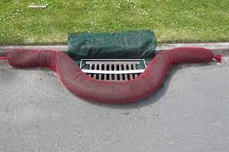

Example of sediment sock protecting drains.

* 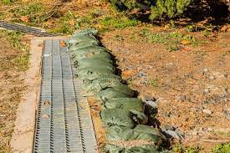

Example of sandbagging stacked together to protect drains.

* 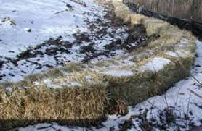

Example of straw bales stacked together.

* 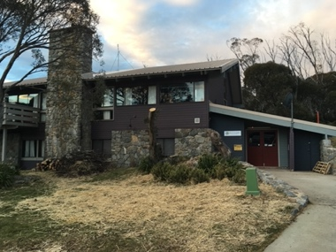

Photo of proposed double hard stand parking space location.

* 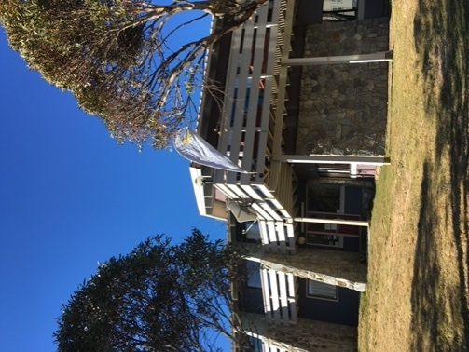

Photo of main deck to be replaced.

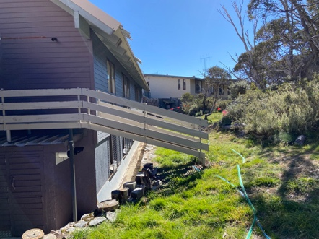

* Photo of rear exit ramp to be replaced

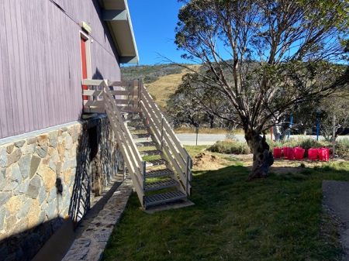

* Photo of north fire stair to be replaced

**Management of native vegetation**

* No native vegetation will be impacted as a direct result of the proposed works of the new deck and the parking spaces. The two new exit structures will also not impact vegetation as they are being replaced in the same location on already disturbed land – photos show this clearly.
* However, clearing of native vegetation behind the building is required in the APZ and consultation has occurred with the RFS and NPWS. See attached documents.

**Waste management**

* A skip bin will be provided to fill with general building waste, then taken to Jindabyne Landfill to be disposed of as per their requirements.
* Smaller items of rubbish can be removed in private vehicles and disposed of correctly.
* The timbers from the deck are to be kept and re-used for other projects.

**Noise and vibration pollution**

* The proposed works will occur outside of the winter ski season months (October to May) during normal business hours.
* The proposed works are small in scale, thus noise will be minimal with typical tools such as hammers, electric saws, nail guns and concrete machinery.

**Air pollution**

* The proposed works will not contribute to air pollution.

**Fuels and chemicals**

* The proposed works do not need to store fuels and chemicals.

**Emergency procedures**

* The tradesmen and contractors involved with the proposed works shall carry their own first aid kits for minor injuries.
* The tradesmen and contractors will have access to inside the building where another first aid kit is located in the office.
* For more serious incidents, 000 should be called for fire, police or ambulance.